Programming Concepts - Tutorial 7
HIT265 – C Programming
Question 1
Apply Prim’s Algorithm to each of the graphs in Figure 1. Don’t forget to include the table of vertex labels and the tree at each stage in your answer. In the graphs where no edge weights are given, assume an edge weight of 1 for each unlabeled edge. Remember to use the alphabetic/numeric convention – this will tell you which vertex to the algorithm at.
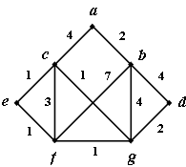
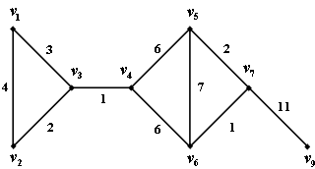
(a)
(b)

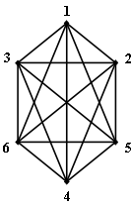
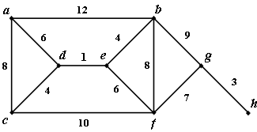
(c)
(d)

Figure 1
Question 2
- Calculate the total weight of each tree produced in question 1.
- Implement Prims algorithm
- Perform Prim’s algorithm again on graph (a) figure 1, this time starting at vertex f. What to you notice about this tree compared with the tree you produced in Question 1?
  - Are the two trees the same weight?
  - Are they isomorphic? Explain your answer.
- Perform Prim’s algorithm again on graph (b) figure 1, this time starting at vertex 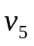. What to you notice about this tree compared with the tree you produced in Question 1?
  - Are the two trees the same weight?
  - Are they isomorphic? Explain your answer.
Question 3
- Is the minimum-weight spanning tree of a graph G always unique? Why/why not? (See parts (b) and (c) of Question 2).
- Will the minimum-weight spanning tree of a graph G produced by Prim’s algorithm give you the shortest path between the starting vertex and every other vertex in G? Why/why not?
(Hint: Refer back to your answers for Tutorial 5 and look at the trees produced by Dijkstra’s algorithm for the graphs in Figure 1).
Question 4
Explain how Prim’s MWST algorithm can be modified to produce a maximum-weight spanning tree.

